Analysis on PyCitySchools:

Overview:

Results from students in schools located within the region have been recorded, documented and analysed. This report will oversee the methodology of analysis, and interpretations reached.

Method:

Target audience was students in the range of Years 9 through 12 from schools within the region. These students were exposed to a standardised test for Numeracy and Literacy based on standard guidelines outlined by ACARA. The results from these tests were then used to outline deficiencies of students within the region. A pass rate for either score was listed as 50%, but a student must have scored above 50% on both tests, rather than average over 50%, to be eligible for notation that they have fluency in both tests.

In conjunction to the tests, data was procured on each school, inclusive of budget, size and privatisation to see whether these showed significant influence on student achievement.

Sample size:

Figure 1 outlines the sample size of the study conducted. Within the study, n=39170 participants were included from the 15 schools within the region.

Figure 1: Overview of sample sizes

Results:

At a regional level: For the region, it was seen that average scores for Numeracy and Literacy were 70.3% and 69.9% respectively (Figure 2). The percentage of students who had the requisite fluency in Numeracy was 86.1%, with Literacy scores being slightly lower at 84.4%. This figure dropped significantly to 72.8% for those passing both tests.



Figure 2: Regional level results

At a school level: As seen in Figure 3, the highest recorded results of any school in the region for average test scores was located at Holden High at 71.7% for reading, and 72.6% for mathematics. These contrasted with the low scores of 68.9% average reading scores at both Huang High and Wilson High, and average math results of 68.7% at Figueroa.

Figure 3: Overall test results of schools (alphabetical)

When looking at percentage above the standards for both literacy and numeracy, schools that breached the 80% mark were Griffin High (81.3), Cabrera High (80.7) and Bailey High (80.1) (Figure 4). This is in contrast to the regional average of 72.8 (Figure 2).

Schools that showed particular struggles within this bracket of testing were Hernandez High (66.4%) and Huang High (66.7%) (Figure 5)

Figure 4: Top performing schools in the region by ‘Overall Passing’

Figure 5: Bottom performing schools in the region by ‘Overall Passing’

Scores on budget: As seen in Figure 6, the highest percentage of students passing both numeracy and literacy was seen in the perceived student budget of $585-630, with the lowest in the bracket of $645-680.

Figure 6: Scores by school budget averaged by student number

Scores by size: When considering the size of each school, it was seen that schools with a population number preceding 1000 students showed higher results compared to those at larger schools (Figure 7).

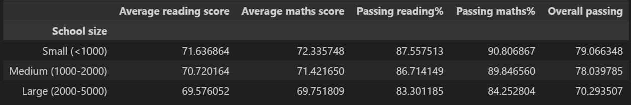

Figure 7: Scores by school population sizes

Scores by privatisation: When comparing score results of schools that are government funded or independent (Figure 8), it can be seen that the pass-rate of students at independent schools is significantly higher than those at government schools (77% to 70.7%)

Figure 8: Scores by privatisation

Discussion:

Overall, it can be concluded that the region has a high level of variation at all levels. Of the data procured, it can be stated that budgets are not a primary cause of lower school scores as lower budgets per student showed higher results, however could be an indication that spending at higher budget schools may be ineffective.

The two factors that showed significant changes within the achieved scores were whether a school was privatised and the overall size of the school. Privatisation showed an increase of 6.3% pass rate, with the government schools being over 2% below the overall achieved pass-rate. It is also seen that 4 of the 7 government schools within the study found themselves in the lowest recorded overall pass-rates.

The size of each school showed an impact on study score when observing the three categories. The difference between schools with less than 1000 students and between 1000-2000 students was at 1%, which is not significant considering both are exceptionally above the regional average. The issue arises when schools reach above 2000 students, where the 7.8% drop puts them well below the average.

For both of these key findings, there is one clear outlier seen within Bailey High School. By regards to both school size (4976 students) and its identity as a government based school, Bailey High far exceeds the expected results, placing as the third highest performing school for overall student pass-rates.

Recommended Follow-ups:

Based on findings from this study, the following steps are recommended:

* Conduct an audit into schools that have the highest and lowest pass-rates
  + What pedagogical strategies are in place?
  + What do attitude to school surveys indicate for both teachers and students?
  + What could be implemented within the bottom performing schools, both resource and strategy based?
* Conduct an audit into schools that are underperforming when budget per student is exceptionally high
  + Where is funding going?
    - Is funding going to non-academic purposes?
    - Does the school have a high instance of intellectual/behavioural funding?
* Conduct an audit into schools that have a high student count
  + What added difficulties do schools with this size possess?
    - How does Bailey High handle these pressures in comparison to similar sizes with lower results?